Seven Rivers 
Resource Conservation & Development Council, Inc.

FY 2018 Plan of Work
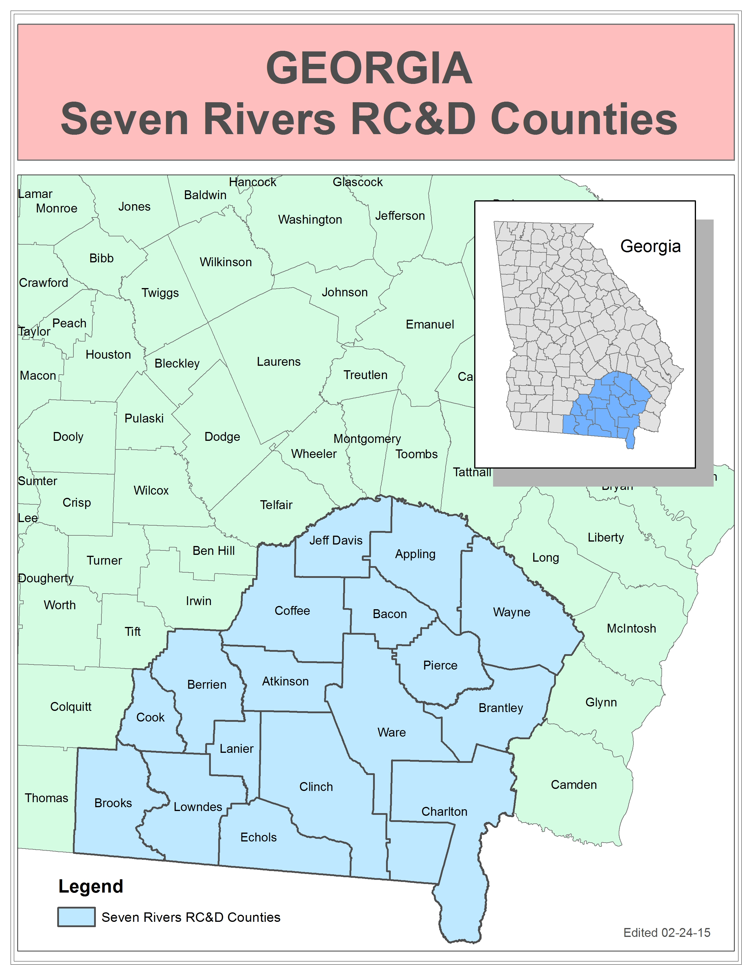
Our Vision Statement is:
Local people working together to develop, enhance, and protect our resources for the betterment of our economy and environment.

Our Mission Statement is:
Our mission is to work together with the local people we serve to improve our communities by exploring opportunities for community growth and development and by seeking solutions to the problems we may face.

Background and Structure of the Council
The Seven Rivers Resource Conservation and Development Council was initiated in March of 1992 by a group of local community leaders in Southeast Georgia. The Council was created out of a realization by these individuals of the dire need for communities to collaborate on finding solutions to common problems, learning from unique challenges, and exploiting opportunities. The Council received authorization by the Secretary of Agriculture, in January 1993 and is a 501 (c) (3), not for profit organization.
The original area consisted of Appling, Atkinson, Bacon, Charlton, Clinch, Coffee, Echols, Jeff Davis, and Ware counties and was bounded by seven rivers, namely: Altamaha, Alapaha, Ocmulgee, Satilla, St. Mary's, Suwannee, and Willacoochee. In 1994, the Council's boundary was extended to include the counties of Brantley, Pierce, and Wayne. Recognizing the needs of surrounding counties, the council expanded again in March 1997 to include Berrien, Cook, Lanier, and Lowndes Counties. With these expansions, the Council's territory now includes three additional rivers (the New, the Withlacoochee, and the Little). The Council expanded again in January 2015 to include Brooks County.

Signature

________________________ ________________
Council President Date

GOAL 1: ASSIST ALL SEVENTEEN COUNTIES IN REDUCING THE EFFECTS OF SOIL EROSION FROM URBAN, FOREST AND AGRICULTURAL LANDS.

Strategies:
1. Participate in Erosion & Sedimentation certification and/or awareness workshops as needed.
2. Participate in workshops on proper design, installation, maintenance, and inspection of Best Management Practices for forestry.
3. Continue to seek Natural Resource Conservation Service Outreach grants for Team Agriculture Georgia.
4 Continue to support Team Agriculture Georgia workshops and provide fiduciary support for account.
5. Provide agricultural conservation workshops, demonstrations and field days activities.
6. Continue to support the annual Conservation Tillage Conference.
7. Participate in solar irrigation management workshop/demonstrations.
8. Provide equipment for area landowners to use for Better Management practices (No Till Drill, Grass landers, Plastic Bedding Machine, Pasture Aerator).
9. Seek funding opportunities and provide assistance to secure firefighting equipment for council area and seek Wildfire assistance funding.
10. Assist public schools and communities with developing and improving environmental education outdoor classrooms and gardens.
11. Seek funding opportunities to assist environmental education projects.
12. Assist in the promotion of environmental education projects hosted in the Council Area.
13. Continue to provide energy audits by contracting with an individual to audit poultry farms.
14. Support Society of American Foresters Program through the Georgia Forestry Commission.
15. Seek Foundation Small Grants for projects in all 17 Counties.
16. Contracting with NRCS to contact Landowners to do Long Leaf Pine Burns.

GOAL 2: PROMOTE ALTERNATIVE ENERGY OPPRTUNTIES TO REDUCE DEPENDENCE ON FOREGIN OIL AND HELP GEORGIA BECOME A LEADER IN PROVIDING ENERGY THROUGH EDUCATIONAL SESSIONS.
Strategies:
- Educate council members and partners by hosting one speaker a year at council meetings who specializes in energy issues.
- Participate in solar powered field days.
3. Provide assistance to private forest landowners to better manage their property.

GOAL 3: ASSIST COMMUNITIES IN THE COUNCIL REGION TO MAINTAIN AND IMPROVE QUALITY OF LIFE.

Strategies:
1. Participate in meetings with solid waste departments, Keep America Beautiful affiliates, Cooperative Extension and local governments in the seventeen county regions.
2. Participate in regional recycling workshops in the Council area to educate community leaders and area residents.
3. Establish trail projects in communities to promote connectivity and recreation.
4. Work with the Regional Commissions in assisting communities to improve recreational facilities in the Council area.
5. Promote the Georgia Forestry Commission’s Urban and Community Forestry Program.
6. Continue to support Altamaha River Partnership (ARP) in promoting eco-tourism.
7. Promote and encourage leadership training for community leaders.
8. Maintain the Wheels to Work program to provide transportation to work for qualified individuals.
9 Maintain the Household Water Wells program to provide drinking water for qualified individuals.
10. Continue to support Friends of Towns Bluff in Jeff Davis County.
11. Provide the Household Water Well Program for Ben Hill, Tift and Irwin counties outside the Council region.
12. Continue to support Special Projects as assistance is requested within our Council region.
13. Continue to employ one individual as Program Administrator and Program Manager in Appling County.
14. Continue to employ one (1) individual as Program Coordinator.
15. Monitor Aril Extractor System for the Georgia Pomegranate Association with the processing of fruit.
16. Write additional grants for Pomegranate & Satsuma growers in support of emerging crops.
17. Provide equipment (Juicer & Aril Packing) for Pomegranates to expand marketing.
18. Help Satsuma grower’s further development production.
19. Provide Tunnel Houses for schools in Bacon and Lowndes to expand their STEM Programs.
20. Provide Schools with Community Facility Grants for needed equipment (Agriculture equipment)
21. Applying for Playground Equipment for Appling County Recreation Department.

GOAL 4: IMPROVE, CONSERVE AND PROTECT THE WATER RESOURCES IN THE COUNCIL AREA.

Strategies:
1. Seek funding for the Willacoochee River Watershed
2. Seek funding for the Alapahoochee River Watershed.
3. Seek funding for the Lower Satilla River Watershed.
4 Seek funding for the Little Satilla &Hurricane Creek.
5. Seek funding for the Altamaha River Watershed.
6. Implementing approved funding for Big Satilla Creek Watershed
7. Implementing approved funding for 17 Mile River Watershed Plan
8. Seeking funding for 17 Mile River Watershed 319 Plan
9. Seek funding for Alapaha River landing improvements.
10. Seek funding for Altamaha River Towns Bluff sand dock.
11. Participate in BMP field days to promote Best Management Practices for the reduction and prevention of livestock wastes.

